**Sonic Pad**

**Firmware Burning Tutorial**

**（**Windows**）**

|  |  |
| --- | --- |
| Version | V1.1 |
| Date | 2023/2/10 |
| version record | V1.0 initial version  V1.1 Chapter 4 Add Notes Before Burning |
| editor |  |

**Shenzhen Creality 3D Technology Co., Ltd**

**Catalog:**

1. Tools： 3

2. Enter the burning mode 3

3. Driver Installation 3

4. Sonic pad firmware burning 7

## Tools：

1. PhoenixSuit.zip

2. (burn firmware) t800-sonic_lcd_uart0_1.0.6.40.112.img

3. Male to male USB cable( TYPE-A TO TYPE-A)

## 2. Enter the burning mode

1. When the Sonic pad is turned off, insert the USB cable into the CAM port
2. Press and hold the FEL button on the right with a paper clip
3. Press the Power button to power on the Sonic pad, then the Sonic pad will enter the burning mode

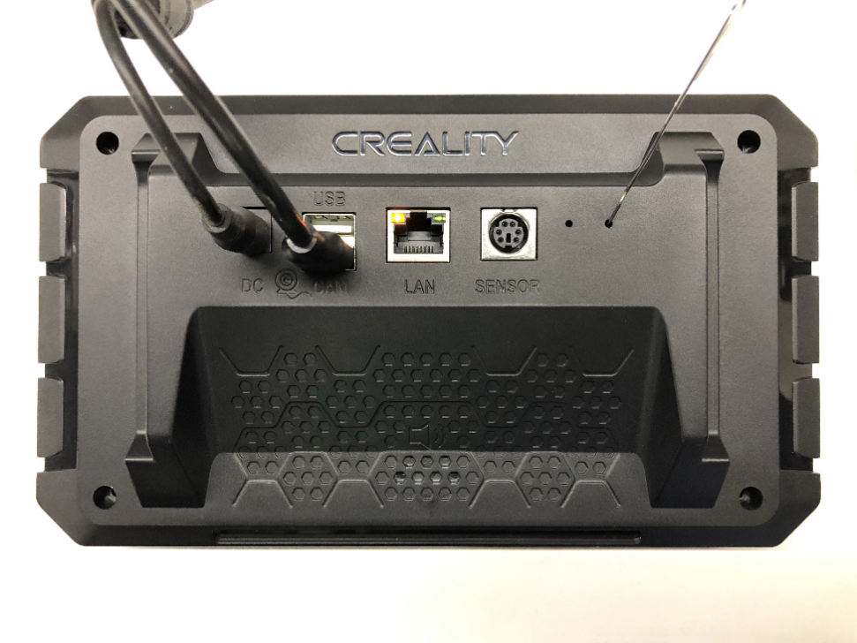

FEL

Power

## 3．Driver Installation

Before using the burning tool for the first time, you need to install the driver. Let the device enter the burning mode according to Chapter 2, open the PC-side device management, there will be an unknown device, install the driver according to the following steps.

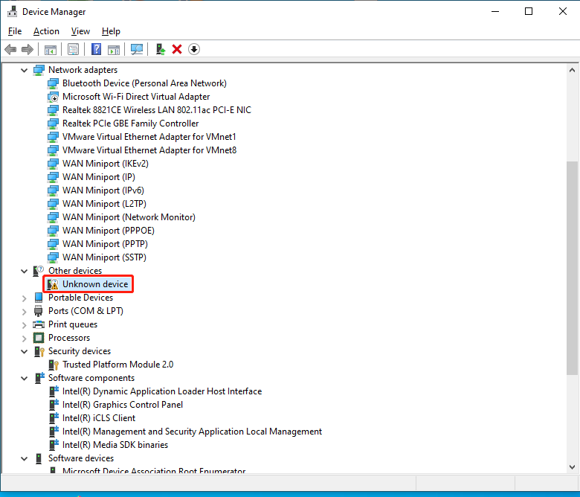

1. Double-click "Unknown device" to pop up a dialog box to install the driver
2. Click the "Update Driver" button and choose to install the driver manually

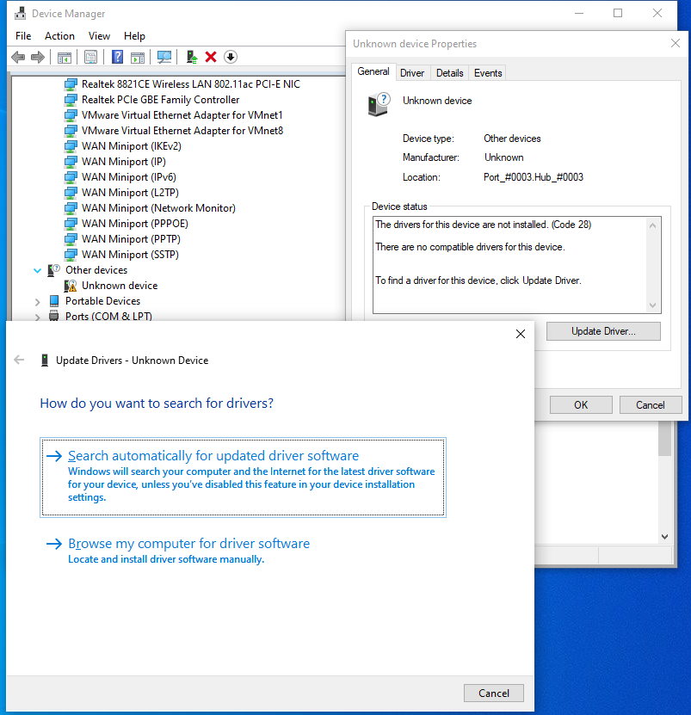

1. Select the Drivers folder under the PhoenixSuit directory

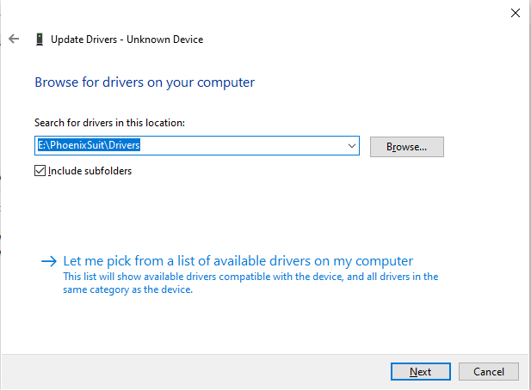

Driver installed successfully

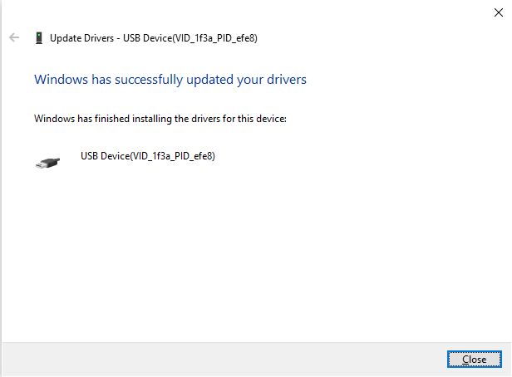

## 4. Sonic pad firmware burning

Notes before burning the firmware: Run the phoenixsuit software first, connect the Sonic pad to the computer with a male-to-male USB cable, and then let the Sonic pad enter the burning mode. The specific steps are as follows:

1. Open phoenixsuit, as shown in the figure below, select the firmware to be burned

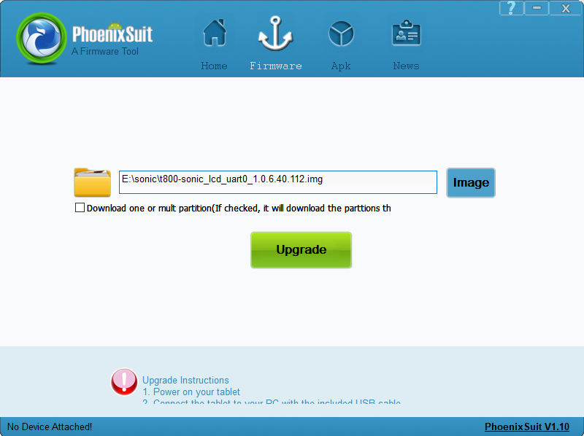

1. Connect the Sonic pad to the PC and enter the burning mode (please refer to Chapter 2). The following page appears, click the "Yes" button(If the following interface does not appear, the device manager installs USB_driver)

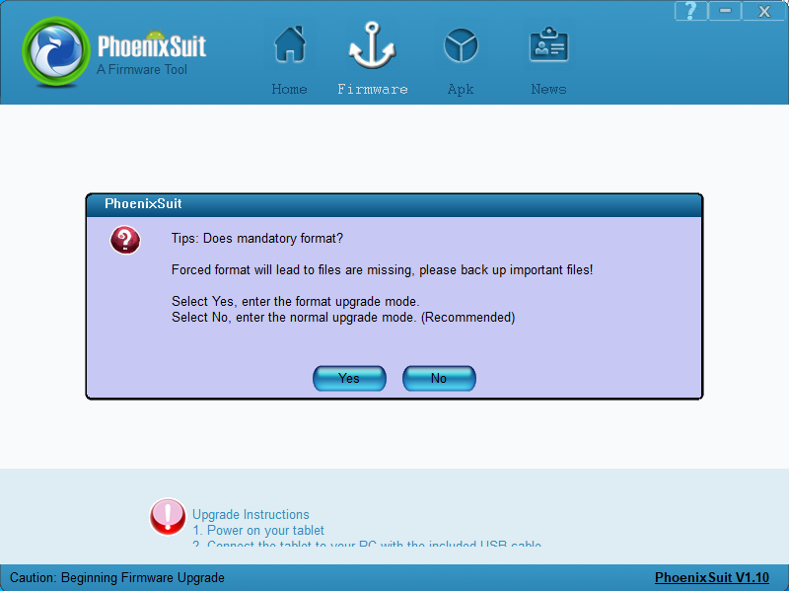

burning...

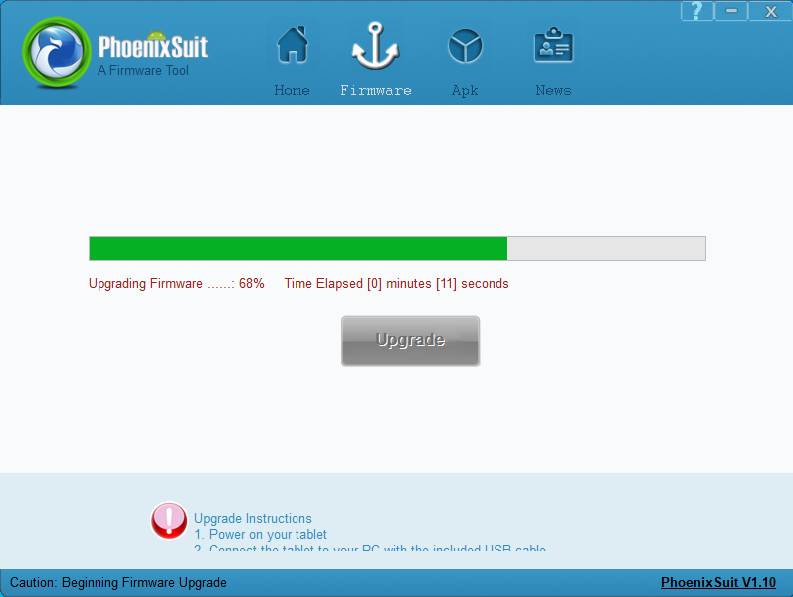

Burning is successful, the device restarts automatically

